SCT Power Supply System
SCT Patch Panel Three (PP3)

___________ DRAFT 6 ___________

Abstract
This note describes the planned implementation of the SCT Patch Panel Three (PP3), including specifications, circuit layout, magnetic shield, rack allocation and rack internal layout. Remaining open issues are highlighted in red.

Prepared by : |  |  | Checked by : |  |  | Approved by :
G.F.Moorhead,
S.Gregory
 | for information,  you can contact : | G.F.Moorhead |  | Tel.  +61-3-8344-5075  +41-22-767-8946 | Fax. |  | E-Mail  gareth.moorhead  @cern.ch

History of Changes
Rev. No. | Date | Pages | Description of changes
1 | 09-May-2003 |  | GFM. First draft
2 | 16-May-2003 |  | GFM. Incorporate ‘final rack allocations’ from Sergei Maluykov, EDMS reference ATC-TB-EP-0007 version 1 released 16-May-2003.
3 | 03-June-2003 |  | GFM.
4 | 13-June-2003 |  | GFM. Comment from Steve Gregory on circuit layout.
5 | 18-June-2003 |  | GFM. Incorporate comments from PP3 Working Meeting held at Uppsala SCT Week, 17-June-2003.
6 | 01-March-2004 |  | GFM. Incorporate change to rack layout, recent field results. For the review to be held during SCT Week, 09 March 2004.

1. Introduction:

Patch Panel Three (PP3) is implemented as individual isolated units, one per module cable, located in racks mounted on the HS structure surrounding ATLAS in the UX15 cavern.

PP3 provides:
- Interconnection between the heavy gauge Type IV cable from the power supplies located in the two neighbouring caverns US15 and USA15, and the lighter gauge Type III cable running into the ATLAS detector.
- Common-mode inductive filters on all lines, both power and control, to attenuate any common-mode noise that may be picked up on the long run of Type IV cable.
- Voltage limiter circuits for the high current 3.5V analogue and 4.0V digital IC power circuits. The voltage at the power supplies is much higher than that at the modules to account for the voltage drop on the long cable. This voltage significantly exceeds the safe voltage at the ICs, where it could appear under some accidental scenarios where the current drops suddenly.

Implementation constraints include the necessity to shield against the strong fringing magnetic field in the vicinity of the ATLAS Barrel Toroids which may exceed the saturation field of the inductive cores, the necessity to preserve the grounding continuity and isolation conditions, the very high packing density of cable and PP3 boxes required in the available rack space in UX15, and the necessity for reasonable access for rapid maintenance.

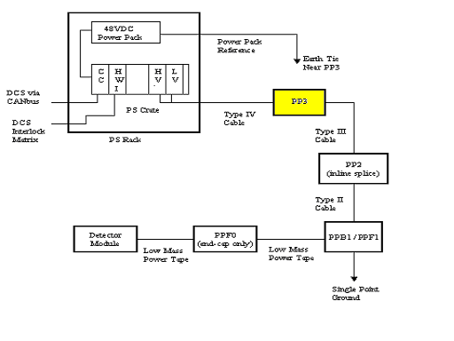
Figure 1: Power Supply Block Diagram [1]

2. PP3 specifications

Common-mode rejection, Vdd/Dgnd and Vcc/Agnd | ???
Common-mode rejection, all other conductors | ???
Maximum tolerable ambient magnetic field (outside shield) | 600 G
Voltage limit, Vdd-Dgnd at module measured on sense lines | 5.20V ± ???V
Voltage limit, Vcc-Agnd at module measured on sense lines | 4.50V ± ???V
Maximum weight of one PP3 rack mounted on HS support beams | 500 kg ?
Time to access and replace any individual PP3 unit in a rack | 1 hour ?

The voltage limiter is required because the maximum voltage at the power supply significantly exceeds the maximum allowable voltage at the module ICs due to the large voltage drop on the cables and power tapes. The maximum design current for both analogue and digital supplies is 1.3 A. The one-way resistances in the corresponding power circuits are up to 4.0 Ω, leading to maximum total voltage drop of 5.2 V each way, [2]. Under certain circumstances, for example a failure of the clock leading to a sudden reduction of current, this can lead to an unacceptable voltage at the ICs more rapidly than the power supply microcontroller can react.

The common mode filters are required to attenuate any noise picked up on the long cable runs from the power supplies. All conductors, including the cable screen drain wire, pass through a common mode choke. The metal box is electrically connected to the module side of the screen choke. The metal box and the cable screens are electrically isolated from contact with any other PP3 and all surrounding structures. The ground plane in the PCB is split at the screen choke.

The fringing magnetic field of the ATLAS Barrel Toroid may be up to around 600 G in the vicinity of the rack positions on the HS structure, typically 3 or more metres from the nearest toroid coil. The positions of the PP3 racks are defined by TC documents in EDMS [4]. Simulated field maps for the ATLAS cavern UX15 are also in EDMS [5].

Several further requirements relate to the supporting structure for PP3. A number of rack positions have been allocated in the UX15 cavern according to many constraints from cable routing and location possibilities on the HS structure. They will be standard ATLAS 41U racks. The racks must be supported on the HS eight-level scaffold structure which surrounds the ATLAS detector. The HS structure is made of steel beams, with the racks positioned directly over beams for maximum support. The PP3 racks, fully loaded with cables, PP3 units and magnetic shields, must not exceed the weight tolerance. Furthermore, magnetic forces on ferro-magnetic material may be non-negligible.

Another significant constraint is that individual PP3 units should be reasonably accessible for maintenance. Should a PP3 fail in service, it would be desirable to be able to replace it rapidly. This imposes constraints on the internal layout of PP3 and cabling inside the racks. There may be up to 300 each of Types III and IV cables in the rack which are likely to obstruct replacement of any individual PP3. Diagnosis of a PP3 failure is a separate and non-trivial issue. However, as a device which is in principle accessible, we should certainly allow for the eventuality.
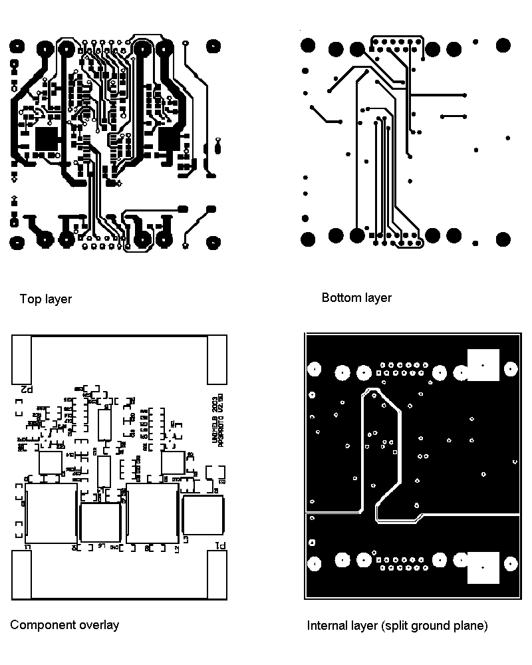

Figure 2: PCB layout: PP3 version 3.0 with 17W5 D-sub connectors

3. Circuit design & layout

The circuit schematic [6] and bill of materials [7] for the baseline design of PP3, version 3.0, are available. This version uses 17W5 combination D-sub connectors, of the same configuration as used at the power supply backplane.

The baseline PP3 consists of a rectangular printed circuit board, 70 x 85 mm. Board layout is shown in figure 2, and a photograph of a prototype of this design is shown in figure 3. All components except the connectors are SMD to minimise area, reduce assembly cost and enhance reliability. All components are mounted on the top surface. The PCB is 2.4 mm thick for extra stiffness, without being too thick for soldering the connector leads. Copper plating is double weight, 1 oz/sq.inch, to minimise resistance. The board is hot-air levelled (HAL), i.e. plated with solder over the copper to further reduce resistance. It is coated top and bottom with a solder-mask, and finished with a top overlay legend.

The 17W5 combination D-sub connectors are at either end, connecting to both cables with identical pin assignment to the power supply backplane. The input connector for Type IV is a plug on the PCB, and the output connector for Type III leading to the modules is a socket connector, identical to that of the power supply crate backplane. Opposite gender connectors prevent incorrect connection. Circuit topology is simple with connectors mounted on the same surface of the board, as the traces run generally in-line without need for crossing from one side to the other. The specified right-angle PCB connectors are flush with the surface of the board for extra stiffness and reduced box height. The connectors for the prototypes have been procured from Conec Corporation. An alternative supplier, FCT Electronic Gmbh, is also under consideration.

Printed circuit board marterial is halogen-free FR4. The final circuit will be laid out to conform to IPC-221, in particular for the HV traces. A 5 mm clearance is allowed in most areas between the HV tracks and any neighbouring conductors or the edge of the board, with further isolation provided by the solder-mask coating. The mixed D-sub connector includes fully specified and well-shrouded high-voltage connector and socket inserts. It also provides on the cable side high-current crimp connections designed for the 8-10 gauge wires, a feature particularly difficult to obtain in other compact connector options.

The board is implemented in four layers as follows:
Top layer: | All high-current and "crowbar" tracks, layed without vias  to improve reliability.
Ground plane: | Split between grounds connected before and after common-mode chokes.
Middle layer: | Redundant low-current paths (exact duplicate of the bottom-layer) for improved reliability of vias.
Bottom layer: | Low-current paths.

The common-mode suppression circuits are implementations of the design by Ned Spencer using his recommended chokes. The chokes are commercial devices from Pulse Engineering, part numbers P0422 for the two high current circuits, and P0354 and Fil-Mag 23Z105SM for the low current circuits. The voltage limiter circuit is an implementation of that developed by the Ljubljana group [3] using closely similar, but not necessarily identical, components from different suppliers. We expect that the radiation environment is not sufficiently severe to cause concern for the degradation of the transistors used.
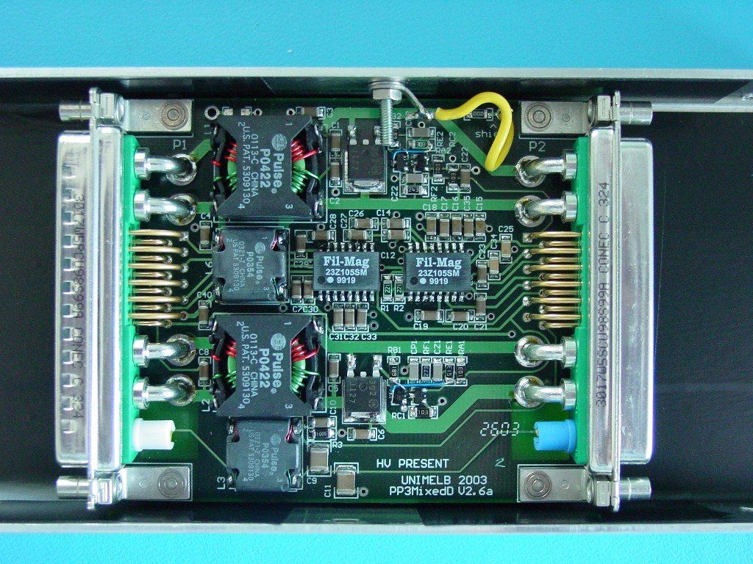
Figure 3: Prototype PP3 version 3.0
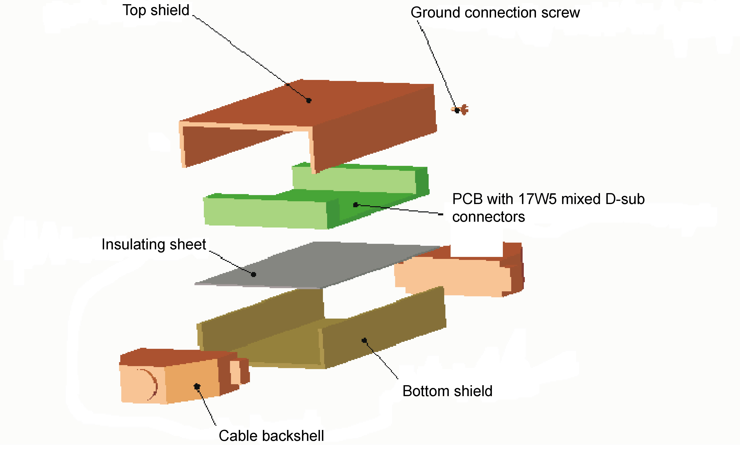
Figure 4: Magnetic shield assembly

4. Magnetic shield & mechanical layout

The magnetic and electric shield concept is illustrated in figures 4-6. The box material is fabricated from sheets of 0.5mm thick grain-oriented silicon transformer steel by RFI Pty Ltd . This material has a thin coating of varnsh. Two C-section pieces are spot-welded together to form a rectangular cylinder with internal dimensions 70 x 19 mm. The length will be around 200 mm, to be finalised shortly. Shields will be manufactured by RFI. This geometry is determined by the shape of the 17W5 mixed D-sub connectors used on the printed circuit boards, for which no acceptable alternative was found.

The PP3 racks will be located in the residual field of the ATLAS barrel toroids. Simulated field maps indicate that up to 600 G may be present. The inductive chokes used to attenuate common-mode pickup saturate at external fields around 100-200 G [8,9]. Allowing for a safety margin, we will require the final shields to reduce 600 G oriented at any direction relative to the shield to at most 50 G over the volume occupied by the chokes. This can be achieved by optimisation of the length and the number of layers of transformer steel.

The magnetic shields will additionally act as electrostatic shields, extending over the lengths of the two cable connectors. The shield will be connected by a short lead to the cable screen conductor, downstream of the chokes. They will be insulated to prevent ground contacts with each other and with the rack structure. The insulation will also act as a safety isolation in case of accidental appearance of the detector high voltage on the shield. The transformer steel is supplied coated with a thin varnish. However, to ensure a suficiently tough insulation, the final assembled shields will be dipped in a conformal coating material.

The cable backshells at PP3, on both the type IV and type III cables, have yet to be finalised. However, it is assumed they will be unmetallised plastic with 90º cable entry. The cable screen drain wires are connected through the 17W5 signal pins to the PP3 ground planes. This connection is expected to be reinforced by an additional low inductance metal or metallised kapton foil inside the backshell. Electrostatic screening of the wires in the connector is by the extended PP3 shield. The backshells to be fitted to the production cables should be selected to fit inside the dimensions of the apertures of the open faces of the PP3 shield.

The shield concept is illustrated in figure 4. The printed circuit board is isolated from the metal shields by a sheet of plastic insulation. The circuit board will be glued to the insulating sheet, and the insulating sheet to the centre of the bottom shield, with Araldite. The transformer steel clam-shells are spot-welded together to ensure minimum air gap for magnetic shielding efficiency. The shield is sufficiently long to enclose the circuit board as well as the two cable backshells.

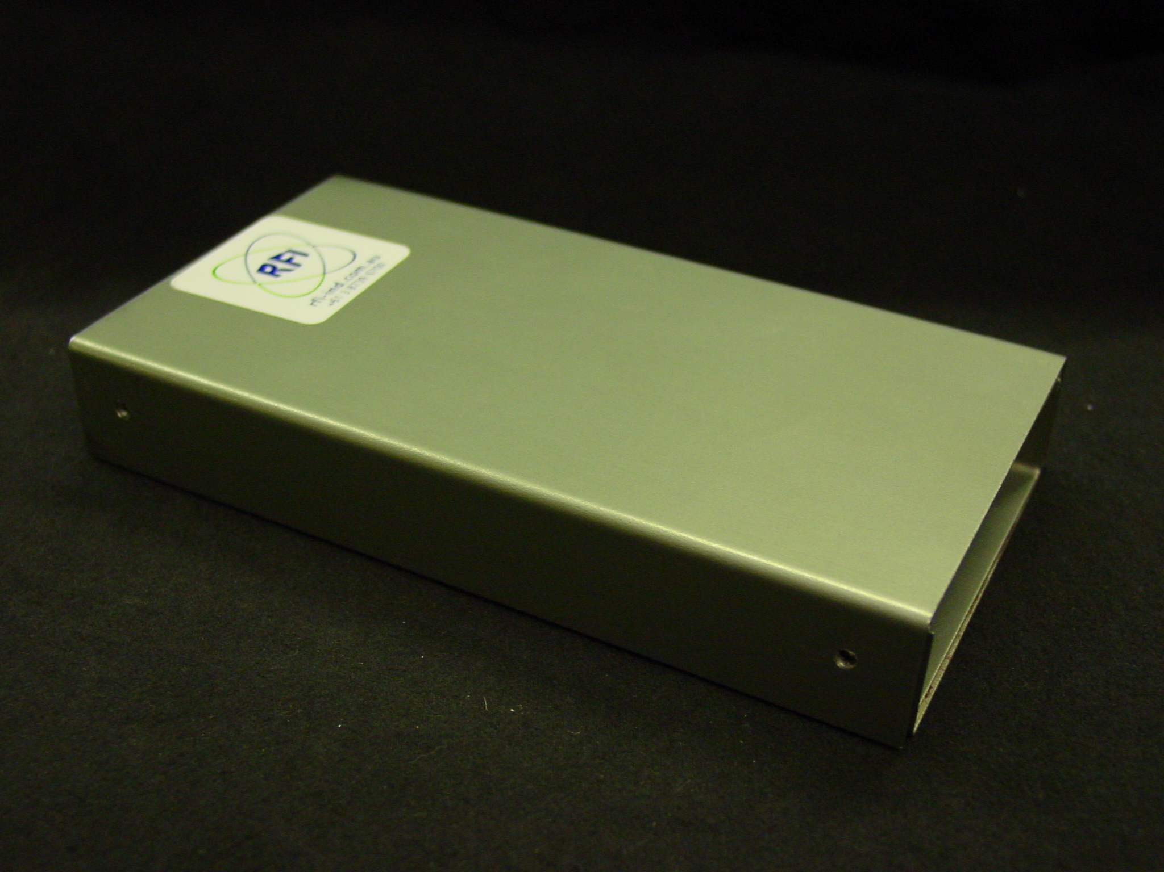
Figure 5: Magnetic shield box prototype

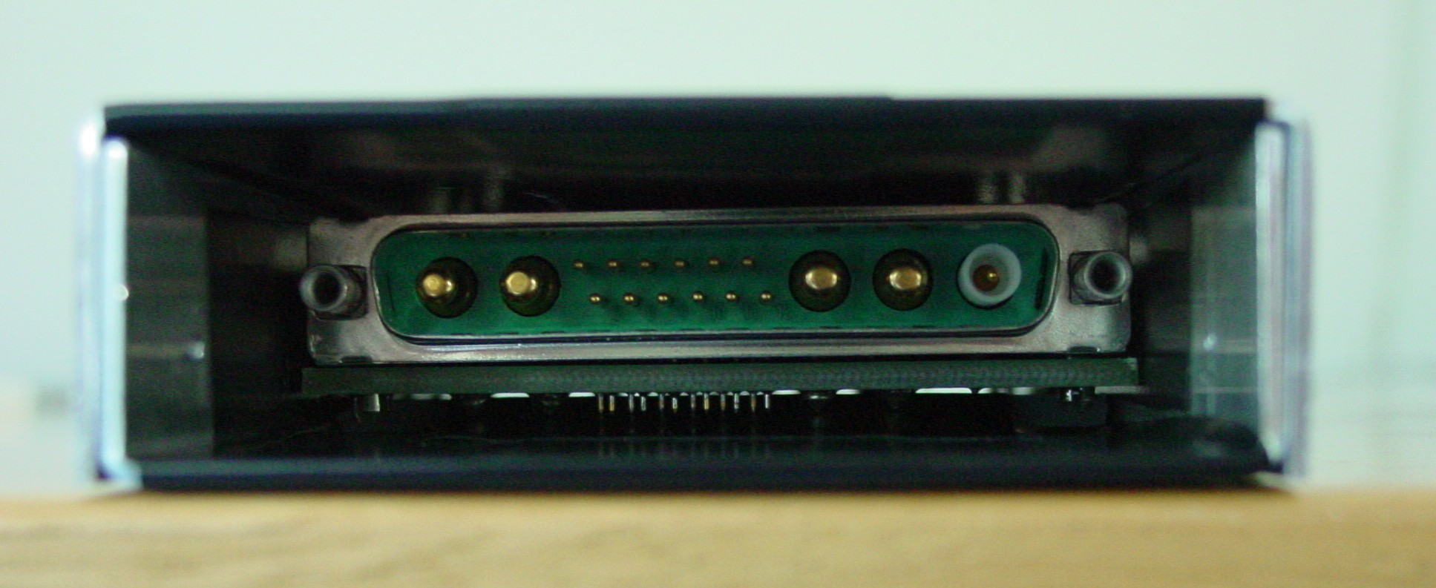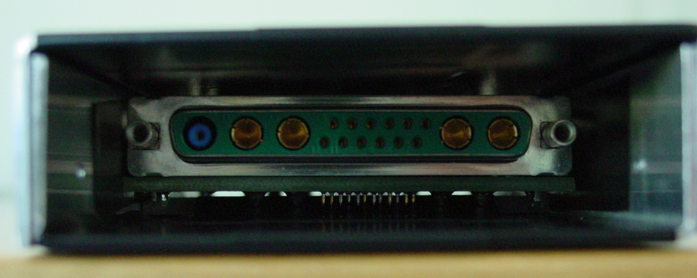
Figure 6: End views of PP3 in shield.

5. Magnetic shield performance measurements

The baseline magnetic shield performance has been tested in several ways. The field strength inside the shields has been measured directly using a Hall probe. Also, the direct effect on the frequency characteristics of the cores inside the shields has been measured as a function of external field strength. It should be noted that in the case of the latter technique, the orientation of the toroidal cores in the flat plane of the PCB and shield leads to an insensitivity in the direction normal to the PCB and shield flat surfaces. Consequently, the orientations of interest are those through the open aperture and through the narrow edge of the shield.

The first shield design proposed utilised a sandwich structure with a core of aluminium. This is a standard approach to achieve good high frequency shielding which is not necessary in this case. Instead, the gap between magnetic sheets at the overlap of the separately formed ‘C’ pieces, forced by this construction, lead to insufficient low frequency performance. This was shown in measurements in the large Morpurgo superconducting magnet at CERN during July 2003 [12] where significant degradation could already be detected at around 200 G ambient field strength in the two directions of interest.

Following these results, the shield design was changed to simple boxes of silicon transformer steel, spot welded where the ‘C’ pieces overlap to ensure good magnetic coupling. Two basic designs have been pursued, single thickness and double thickness. Prototype shields 164 mm long with inside dimensions 22 mm and 75 mm were constructed. Two types of test have been performed in Melbourne, low field and strong field.

In the low-field tests [11], a Helmholtz coil was used to generate a field of around 9 G over a volume sufficiently large compared to the shield dimensions to investigate geometry dependence. This field was insufficient to investigate shield saturation effects. The measurements have limited usefulness due to the residual field inside the shields and the measurement errors. However, they demonstrated an order of magnitude reduction in field strength over the volume inside the shield to be occupied by the chokes. Figure 7 shows the field as a function of position for the orientation shown, the shield narrow side in the field direction. The field reaches its minimal level of around 0.5 G at around 50mm from the centre along the shield axis, and is uniform across the width. A similar result was found for the field oriented towards the aperture, where the increase started around 35mm from the centre. This was the case for both shield thicknesses, i.e., no strong dependence on thickness was observed in the two directions in which the chokes are expected to be sensitive. With field perpendicular to the flat surface, the internal field was around 1.8 G for single layer shield, and around 0.9 G for a double layer shield, indicating in this direction the shielding effectiveness does depend on thickness.

In the high-field tests [12], a laboratory electromagnet was used to generate fields between its pole faces of up to around 800 G for the later shield designs. In these measurements, the field strength exceeds the values of interest, but the geometry is highly non-uniform over the size of the shields due to the pole face diameter of only 90 mm. Furthermore, the separation of the pole faces is insufficient to fit the shield longitudinally. Nevertheless, these tests are interesting because they demonstrate the saturation behaviour of the shielding material. For the field oriented as shown in the previous figure, towards the narrow edge, the results in Gauss at the centre of the shield are

External | Single | Double
200 | 0.2 | 0.4
400 | 15 | 1
600 | 90 | 3
800 | 185 | 25
from which we can conclude that the double thickness shield is adequate to strengths well in excess of the 600 G target value. The single layer shield does not quite meet the target performance of 50 G in an external field of 600 G. However, as noted previously , the chokes continue to function in fields up to 100 G. Furthermore, these tests are of shields in isolation. In the PP3 racks, multiple shields will be close neighbours which should tend to reduce the field at least for the inside units.

Several further tests are planned before a final design is proposed. Firstly, new prototypes with lengths of 200 or 210 mm will be manufactured. This is the length determined to enclose the cable connectors as well as the circuit board. These prototypes will be tested to field strengths well in excess of 600 G in a large, strong magnet at CERN during the second quarter of 2004. As the superconducting Morpurgo magnet is not available this year, the new H8 water-cooled MBPS magnet will be used as soon as installed. Thiss is expcted to be in March or April, prior to the SPS startup in May.
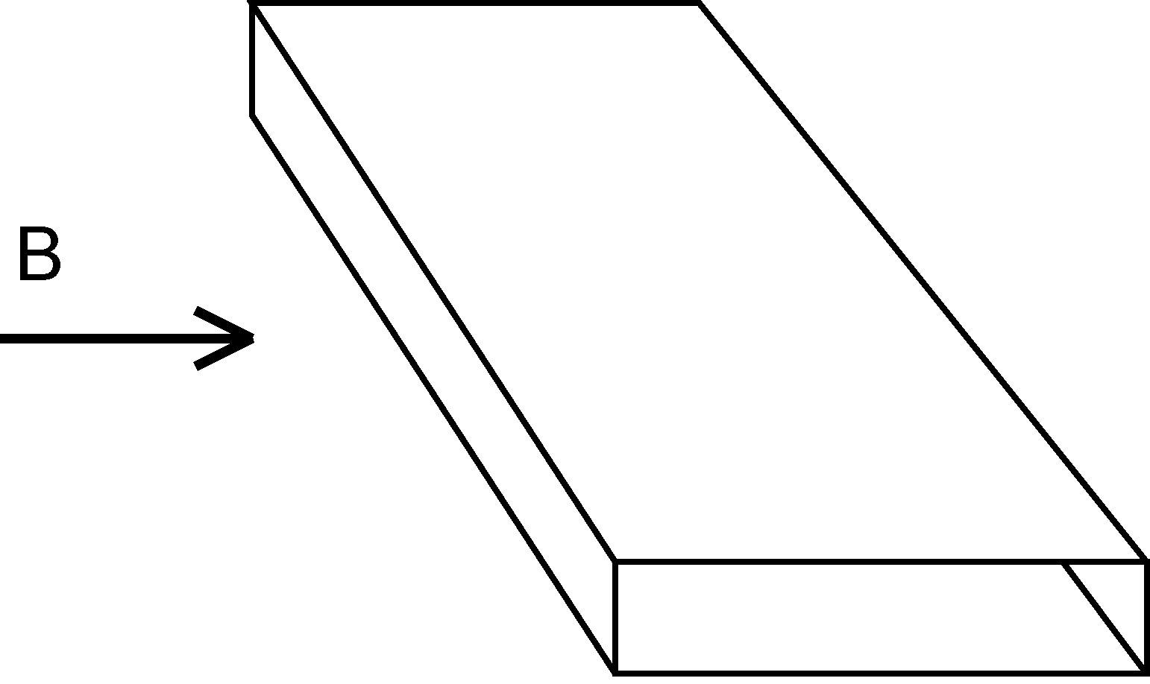
Figure 7: Helmholtz measurement, field applied in the Z direction, measuring Bz(X) at Z=0 and
Bz(Z) at X=0.

6. Cable routing & rack allocation in UX15

PP3 should be mounted as close as practicable to the modules to minimise the length of and hence voltage drop on the much more resistive Type III cable, as well as to minimise the fraction of cable length not filtered by the common-mode chokes. Additionally, PP3 should be sited to minimise deviation from the most efficient cable routing to keep the combined lengths of Type III and Type IV cables as short as possible. Practical choices for PP3 siting are considerably constrained by the available rack spaces on the HS structure and also by the practical routing of the massive cable bundles along the foreseen cable trays. PP3 rack allocation has been performed by Sergei Malyukov of TC as part of the cable routing optimisation process for all ATLAS cables, in consultation with the SCT. There have been a number of revisions as more racks have become available, reducing the installed cable densities.

Final PP3 rack allocations on the HS structure in UX15 are defined in ATLAS document ATC-TB-EP-0007 on EDMS [@4], reproduced in table 1. The locations on either side of the cavern are shown indicatively in figure 8. The two sides face the US15 and USA15 caverns respectively. PP3 racks are yellow. Figure 9 is an indicative view of the cable routing.

PP3 racks with the numbers of PP3 units and packing density calculations are shown in table 1. These racks will be standard ATLAS 41Ub electronics racks, 60 x 90 x 190 cm. However, they should not be fitted with electricity supply, cooling or ventilation. The cavities in the rack side walls normally used for ventilation and cooling water pipes should be vacant as they will be used for cable routing.

At time of writing, a further revision of the racks on the higher levels of the US15 side is underway due to the recent release of a number of racks by the muon gas system.

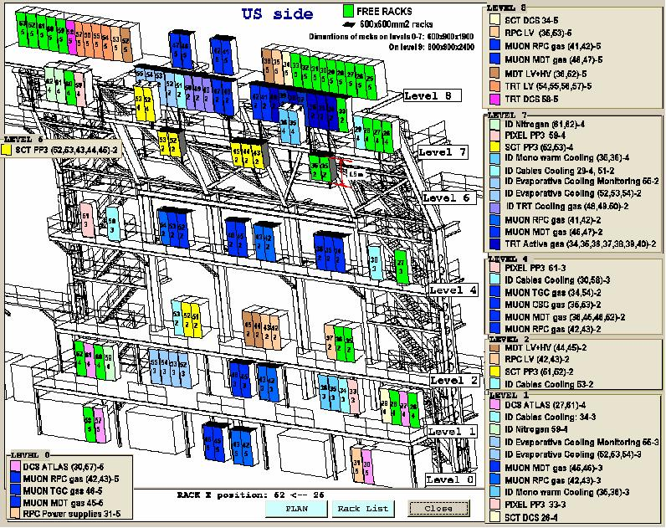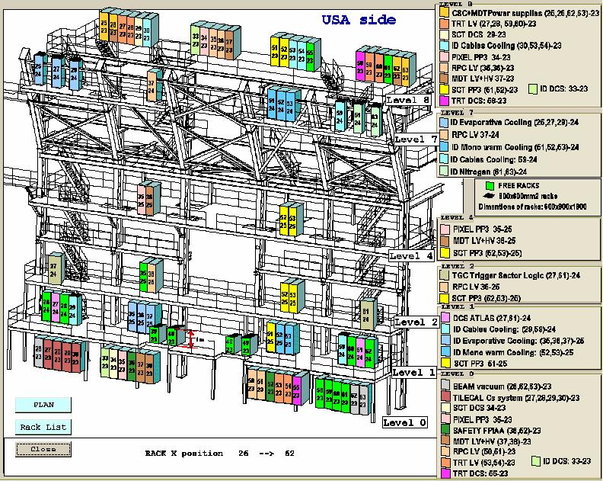
Figure 8: PP3 rack positions in UX15, in yellow. Unallocated racks are bright green.

Table 1 : Rack allocation & cabling
PP3 Group | Location | Total cables | Cables / rack | Rack ID | Type | W (cm) | D (cm) | H (cm) | Footprint (sq.cm) | Sq.cm / cable | Volume (cu.cm) | Cu.cm / cable
PP3_1 | Cote US/Level 6 | 880
 |  |  | 126 | 02-35 | 60x60 | 60 | 60 | 150 | 3600 | 28.57 | 540000 | 4286
 |  |  | 126 | 02-36 | 60x60 | 60 | 60 | 150 | 3600 | 28.57 | 540000 | 4286
 |  |  | 126 | 02-43 | 60x60 | 60 | 60 | 150 | 3600 | 28.57 | 540000 | 4286
 |  |  | 126 | 02-44 | 60x60 | 60 | 60 | 150 | 3600 | 28.57 | 540000 | 4286
 |  |  | 126 | 02-45 | 60x60 | 60 | 60 | 150 | 3600 | 28.57 | 540000 | 4286
 |  |  | 126 | 02-52 | 60x60 | 60 | 60 | 150 | 3600 | 28.57 | 540000 | 4286
 |  |  | 126 | 02-53 | 60x60 | 60 | 60 | 150 | 3600 | 28.57 | 540000 | 4286
PP3_2 | Cote US/Level 7 | 584
 |  |  | 292 | 04-52 | 41Ub | 60 | 90 | 190 | 5400 | 18.49 | 1026000 | 3514
 |  |  | 292 | 04-53 | 41Ub | 60 | 90 | 190 | 5400 | 18.49 | 1026000 | 3514
PP3_3 | Cote USA/Level 8 | 584
 |  |  | 292 | 23-51 | 41Ub | 60 | 90 | 190 | 5400 | 18.49 | 1026000 | 3514
 |  |  | 292 | 23-52 | 41Ub | 60 | 90 | 190 | 5400 | 18.49 | 1026000 | 3514
PP3_4 | Cote USA/Level 4 | 880
 |  |  | 293 | 25-52 | 41Ub | 60 | 90 | 190 | 5400 | 18.43 | 1026000 | 3502
 |  |  | 293 | 25-53 | 41Ub | 60 | 90 | 190 | 5400 | 18.43 | 1026000 | 3502
 | Cote USA/Level 2 |  | 292 | 25-52 | 41Ub | 60 | 90 | 190 | 5400 | 18.49 | 1026000 | 3514
PP3_5 |  | 584
 | Cote USA/Level 2 |  | 292 | 25-53 | 41Ub | 60 | 90 | 190 | 5400 | 18.49 | 1026000 | 3514
 | Cote USA/Level 1 |  | 292 | 25-51 | 41Ub | 60 | 90 | 190 | 5400 | 18.49 | 1026000 | 3514
PP3_6 | Cote US/Level 2 | 584
 |  |  | 292 | 02-51 | 41Ub | 60 | 90 | 190 | 5400 | 18.49 | 1026000 | 3514
 |  |  | 292 | 02-52 | 41Ub | 60 | 90 | 190 | 5400 | 18.49 | 1026000 | 3514
All |  | 4096 | 4096
Draft 11 | 20030926

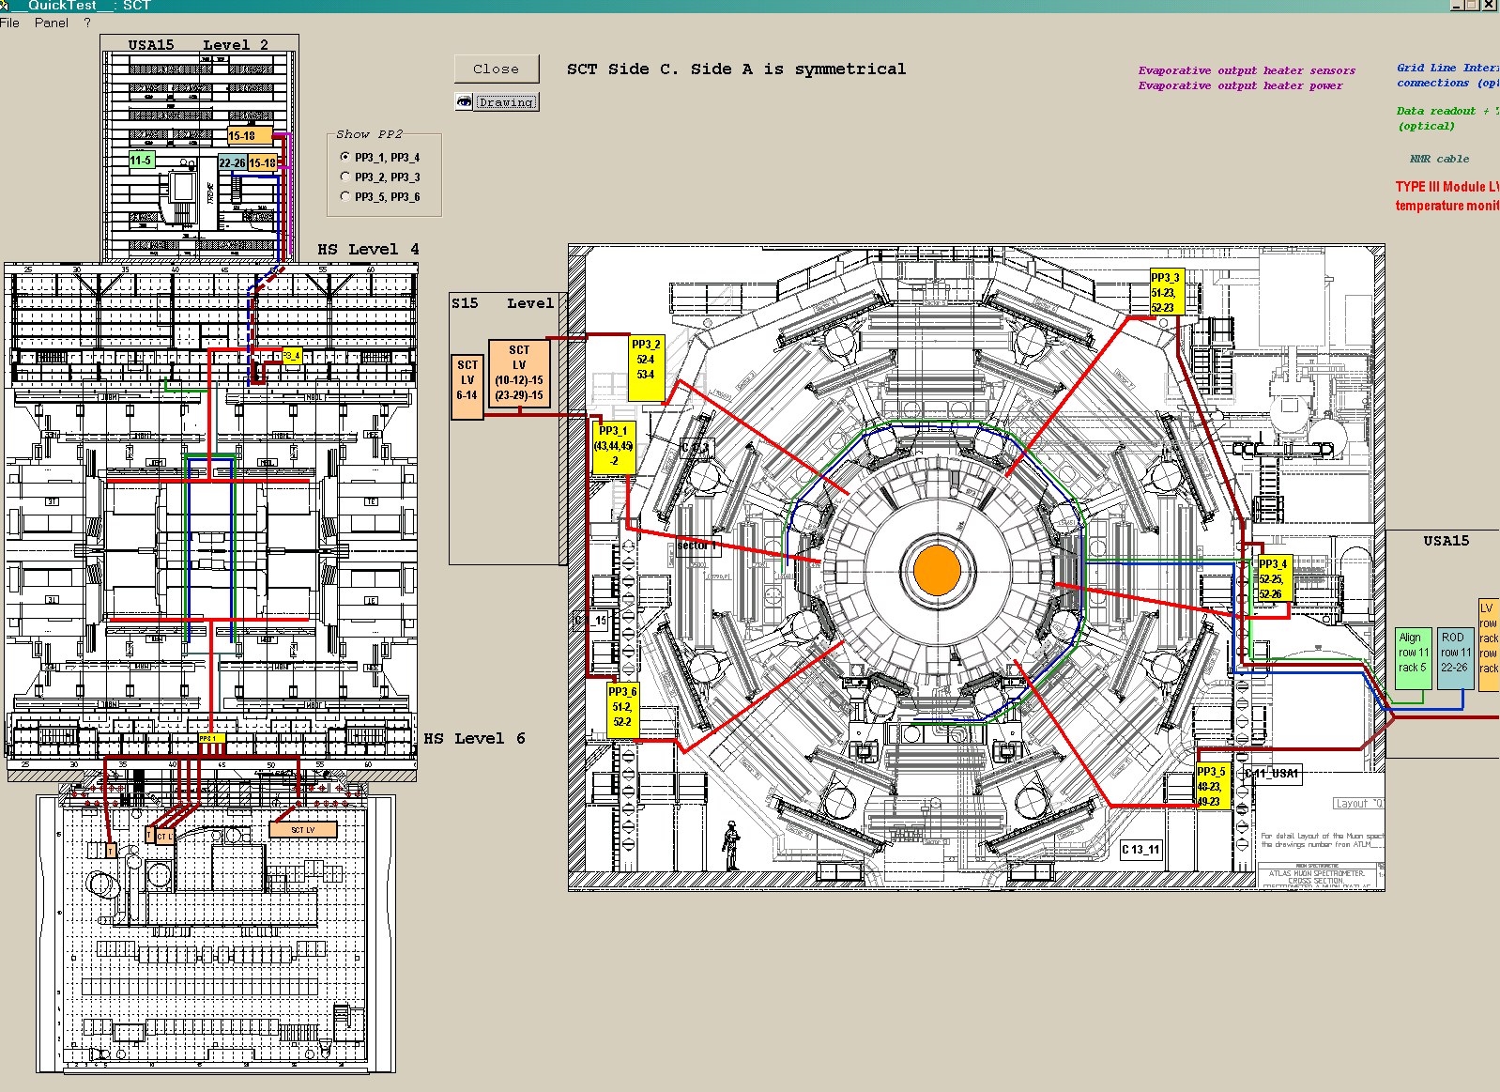
Figure 9: Notional cable routing showing positions of PP3 racks relative to origin and destination of the
six groups of cables. Note: the different caverns are not shown to scale. The final rack allocation is
slightly different to this drawing: refer to detailed drawings on EDMS.
7. Internal rack layout proposals

The rack layout must accommodate 295 PP3 units along with the stiff type III cables and the even stiffer type IV cables. Ideally, the cables will be routed such that individual PP3 units could be exchanged in case of failure. The cables should be strain-relieved and bent through acceptable radii to prevent undue stress on the internal conductors, particularly at any tight bends. The PP3 magnetic shields should be fixed against magnetic forces which arise from the fringing field of the toroids. The cable connectors on both sides should be firmly screwed to the PP3 connectors with jack-screws to ensure reliable electrical connections.

The proposed layout consists of a single column of PP3 units mounted in a 41Ub rack, five units wide and 60 units high, for a total of 300. This allows for up to seven or eight installed spares. The cable bundles are routed in the side cavities of the rack. The 15mm diameter type IV cables in the ventilation space towards the front of the rack, and the 12mm diameter type III in the plumbing space towards the rear of the rack. All racks have access and doors at both front and rear. All cables are routed inside the rack volume, entering and leaving from the floor or roof. Note that in some cases the cables enter and leave trough the same surface, top or bottom, which leads to additional congestion. The cable connectors are all 90º entry. This layout is illustrated schematically in figure 10. Exact mounting details, support bars etc., will be determined through trial layouts using the test cables and electronics racks already installed in building SR1 at CERN during March and April 2004. The racks, recuperated from Delphi, are closely similar to those to be installed in UX15. The test cables are considerably more flexible than either the type III or IV.

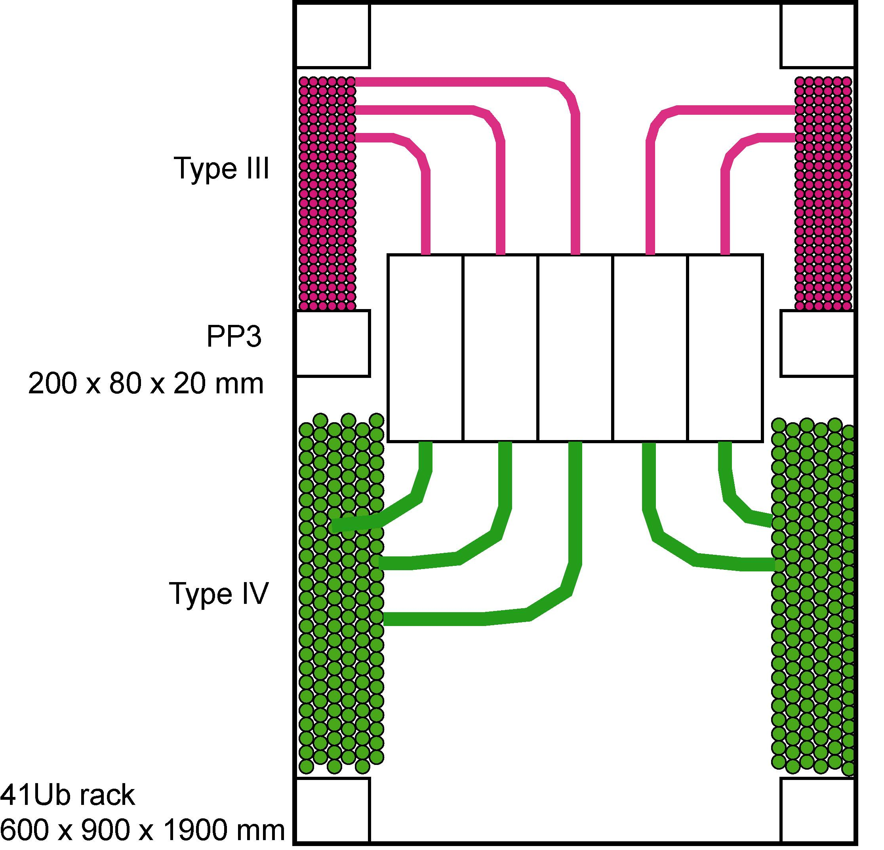
Figure10: Notional rack layout, horizontal sectiom. The PP3 units are stacked five wide, requiring 59 vertical layers to accommodate 295 cables. Allowing 25 mm height including support fixtures results in a vertical extent of around 1.5 m, well short of the rack height.

8. Power dissipation and temperature

The main power dissipation in PP3 arises from the analogue and digital supply currents flowing in the turns of the inductive chokes which have a small resistance [13]. Operating currents are typically around 600 mA for Idd and around 900 to 1000 mA for Icc. Maximum values which should used for thermal calculations are 1.2 A each. Measured total resistances on PP3 including the connectors, the circuit board tracks and the choke turns are between 60 and 70 mΩ for the supply and return circuits. Taking 70 mΩ and 1.2 A for the four conductors leads to a maximum power estimate of P = I²R = (1.2²) * 0.07 * 4 = 0.4 W. The small-signal and detector high voltage lines contribute negligibly in comparison even though their resistances are considerably higher, in the order 300 mΩ per conductor.

It is not planned to cool the PP3 units actively, either with fans or circulated liquid. The main power dissipation occurs in the wire turns of the chokes which are not well thermally coupled to the PP3 metal shield. The PP3 metal shield has electrical insulation which also acts as thermal insulation. The open apertures of the magnetic shields are effectively blocked by the cable connectors, limiting air flow. Conductive heat flow will occur through the PCB tracks to the wires of the cables. The PP3 units will be mounted so as to permit some air-flow around groups of shields.
Some measurements of operating temperatures of insulated PP3 units connected by cables will be performed. An important consideration is the operating temperature of the voltage limiter components. The limiting voltage is given by [3,14]:

Vlim = Vref(1 + Rf/Re) + Vq

where Vref = 2.50 is set by component X1, a TL431 precision shunt regulator, and Vq = 0.65 is the forward voltage drop of Q1, a BC857 general purpose PNP transistor. From data sheets, Vref has a thermal coefficient around 50ppm/°C and Vq around -2mV/°C. At 35°C, ten degrees above nominal, we could expect Vref to rise by 0.5 mV and Vq to drop by 20 mV. Voltage limiter nominal values are 4.50V for Vcc and 5.20V for Vdd, i.e., 1.0V higher than nominal operating values.

9. Production

Production will be organised by the University of Melbourne in Australia. It is proposed to procure and populate the PCBs in industry, but to test them in-house. A test kit will also be provided for use during installation in UX15. A significant fraction of the cost of the units will be that of the 17W5 connectors. It may be preferable to procure these in the same order as the 17W5 connectors for the power supply backplane and cables to obtain the best overall price and to ensure compatibility.

10. References & Related Documents

In the following table, [pp3] represents the URL http://epp.ph.unimelb.edu.au/epp/projects/pp3/.
Documents with reference numbers commencing ATL- can be found on EDMS or CDD at CERN.

 | Document reference | Document
1 | ATL-IS-ES-0042 | SCT Power Supply Distribution
2 | Reference ??? | Voltage drops in the SCT power distribution
3 | [pp3]/docs/LimReport.pdf | Voltage limiter circuit  The Ljubljana ATLAS group
4 | ATC-TB-EP-0007 | ATLAS rack layout in USA15, UX15 and US15 caverns
5 | ATC-TF-ER-0001 | ATLAS Cavern Magnetic field Calculations
6 | [pp3]/pcb/v3.0/PP3_V3.0.pdf | Circuit schematic, PP3 Version 3.0
7 | [pp3]/pcb/v3.0/PP3_BOM_04.txt | Bill of Materials, PP3 Version 3.0
8 | [pp3]/magnetic_shielding/NO_SHIELD_TESTS.DOC | A study of choke core saturation with field strength
9 | [pp3]/magnetic_shielding/P0422_INDUCTOR_TEST.DOC | A study of choke P0422 core saturation with field
10 | [pp3]/magnetic_shielding/SHIELD_TESTS.DOC | PP3 magnetic shield performance – high-field measurements in Melbourne
11 | [pp3]/magnetic_shielding/shieldtests2.xls | PP3 magnetic shield performance – low-field Helmholtz measurements
12 | [pp3]/magnetic_shielding/shieldtest1.xls | PP3 magnetic shield performance – preliminary strong field measurements at CERN
13 | [pp3]/docs/power.txt | PP3 power dissipation estimates
14 | [pp3]/docs/20021004_steve_testresults.txt | PP3 voltage limiter temperature dependence

Conec Corporation, Brampton, Ontario, Canada; http://www.conec.com/
FCT Electronic Gmbh, München, Germany; http://www.fct-electronic.de/
Pulse Engineering, San Diego, California; http://www.pulseeng.com/
RFI Indiustries Pty Ltd, www.rfi-ind.com.au, 52 Holloway Drive, Bayswater 3153, Victoria, Australia, +61 3 9762 6733
Electrical isolation process yet to be finalised.
The cable backshells at PP3 on both the type III and type IV cable may be the same as those used on the macro-assembly power cables purchased by Oxford. These are model number FKC4G from the FCT München company. These backshells fit within a volume 19 mm high, 72 mm wide and 58 mm deep. They are black plastic, fitted with long jack-screws for improved accessibility. An alternative model from FCT, FKC4GA, has the same dimensions but with metalised external coating. It is not proposed to use the metalised version due to the requirement for safety isolation.
The length of the PCB version 3.0 and two cable FKC4G backshells together is 201 mm.
CERN Stores SCEM 06.61.77.100.8, Racks for LHC Experiments.

