Summary of Discussion with Robert Sparks
March 1, 2005

- Floor Plan & Set Up

We went through the floor plan and we made a few changes. You can see that in the figure (I edited the plan from Erin with the changes).
In order to expedite the check-in procedure, we thought about having another table by the entrance opposite to the one already there for greeting.
There will be another table for drinks in the corridor/entrance.
There is also a piano on the stage floor which he promised he will get tuned.
There will be three stations for drinks: the new table for wine, the extra table in the main room for soft drinks, the bar for beers (and of course if people want special cocktails or heavy stuff).
(Melissa, please correct me here, I'm not sure I remember if the beers are from the bar or with the soft drinks)
The small room (by the bar) that we thought could be used by the 8th grader is not available. They will hang out, when not on duty and when they eat their pizza, in the "Grill Room" which is the member’s dining room - not in our floor plan - therefore just remove the label "8th grader".
We discussed at length the telephone connection. The telephone line close to check-out is not a direct line and this is why the credit card machine didn’t work last year (and we had to run a very long cord). But the machine could be programmed to dial 9- from an extension line.
We agreed to go back in the next couple of weeks to try it out. If that doesn’t work will connect (like last year) with the long cord to a far away direct line. But it should work and Theresa will be involved in the test (I already asked her to and she is available to take the earlier trip).

- Schedule (set up start at 9:00 am 11:00 pm end of party – clean up until 12:00?)

Based on Erin requirements, I presented our schedule starting setup at 9:00 am but Robert wants us to start not earlier than 10:00 am since they have an event the night before and they need more time to arrange the rooms for us. I talked to Erin already and she will re-arrange the schedule for the setup work. He confirmed that we'll have until Midnight to clean up.
We discussed the flow of the evening (as I presented) and we all agreed on it:
Displayed Food is at 6:00
Passed at 6:30
Dessert at 8:15
I also include the full schedule in this document (but the set up starts at 10:00).

- Food Plan
  - Suggestions on the Menu
Below I list the menu and our suggestions as I presented and based on their old proposal. Basically I asked to drop (based on Lucy’s suggestion) the chip&salsa, the Onion Tartlettes and the Tuna brochettes. We suggested doubling the amount of other at least 2 other items such as the Chicken Sate and the Thai Noodles.
About the quantity (since we mentioned the fact that last year we run out of food), he reminded us that the passed food is very likely to run out fast because people tend to eat more of that. We then suggested (and he agreed) to keep filling the displayed food items so that at least there will be more to eat. That it’s something they can do more easily than preparing more of the bite size food.

  - Waiver for our own dessert
He will prepare the waiver once we finalize the dessert list and the dynamics of it (Lucy is working on a more detailed plan).

  - Pre-purchasing of drinks
We don’t need to do that. They will charge us afterwards
We found out how much they charge for beers, soda’s and sparkling water.
  - Corkage Fee (final count?)
Same here. They will count how many bottles will be opened
  - Ice
They will provide that.

- Number of Bar Tenders
There will be one bar tender at the bar and a couple of staff at each of the other two drinks stations.

Additional comments:

I think that the drinks should be free (except for special cocktails and hard stuff).
That would include wine, beers and soft drinks (sparkling water and soda’s).

I have the projection of the cost (based on how much people drank at previous events where we served our own drinks) in a separate document.

We’ll go back to discuss final agreement in 2 weeks.
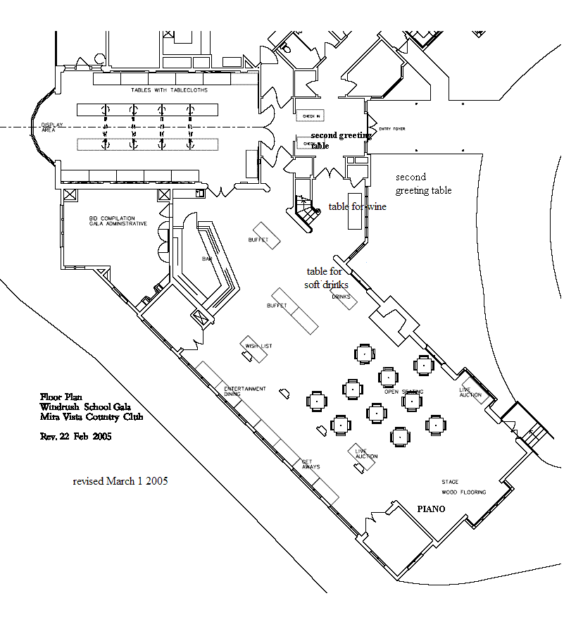

Menu

Displayed Menu

Fresh Vegetable Display with Dip
Seasonal Fresh Fruit Display
Tossed Mixed Green Salad
Smoked Salmon Display with Condiments
Brie En Croute
& Brie En Croute with Pesto
Served with Assorted Crackers & Baguette
Chip & Salsa ------ NO
Antipasti platter & Tapenade with Baguette (NEW)

Passed Menu

Spanakopita
Mini Potato Pancakes with Crème Fraiche & Caviar
Black Beans & Shrimp Quesadillas
Basil, Tomato & Gruyere Toast Point
Chicken Sate with Spicy Peanut Sauce
Goat Cheese & Shiitake Puffs
Onion Tartlettes ----- NO
Parma Prosciutto & Melon
Pineapple & Tuna Brochettes ------ NO
Deep Fried Tofu with a Spicy/Sweet Dipping Sauce
Thai Noodles in Mini-to-go Boxes with Chop stix

Dessert (bite-size provided by us)

Baby strawberry shortcakes drizzled with chocolate
cream puffs with fresh berries
chocolate truffles with cocoa, pistachio and walnuts
chocolate caramel bite sized squares
shortbread cookies
Meyer lemon baby cakes with soft cream

Schedule for Auction Party 2005

April 30, 2005

8:00 am Trucks pick up at School and deliver to Mira Vista
9:00 am Furniture set up complete
Unload trucks
Set up major display decorations, Trees, arches
  - Unpack items
Sort into categories, per plan
Set up display boxes
12-2:00 pm Arrange items
2-3:00 Add Bid Sheets, tags
Add Flowers
Music set up
3-4:00 Check layout

4:00-5:00 Break - Volunteers go home

5:00 8th graders arrive
5:15 greeting volunteers arrive
5:30 greeting table staffed

6:00 Auction Party Begins
Displayed Food
Background Music (Renaissance English)
6:25 Welcome (Lynn, Natasha, Bob)
Alessandra presents: “The Midsummer Night’s Fairies”
6:30-8:30 Passed Food
Background Music (DJ classic Jazz)
7:45 Silent Auction tables begin to close and Data entry
Carla & Mike Zilber (Jazz vocal-piano duo)
8:15 Dessert
8:25 Set up Chairs for live auction
8:30 “Thank you” to Auction Volunteers & Musicians
Live Auction
Set up Check-out tables
9:00 Clear Chairs
Check-out opens
Dancing (DJ favorite tunes)
11:00 Last Check-out closes
Item back to Windrush
Clean-up
12:00 Out of Mira Vista

