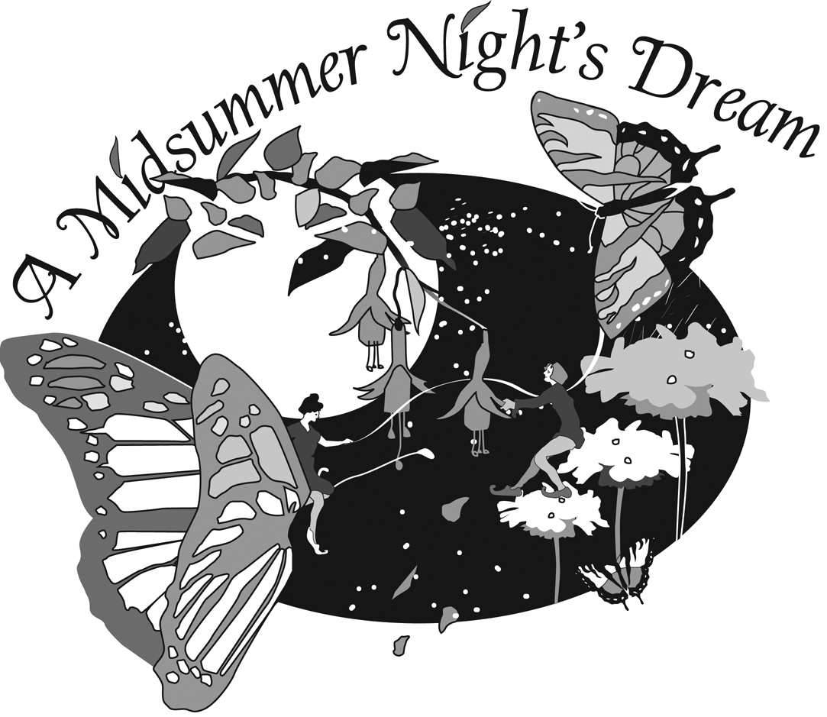

Windrush
Annual Auction Party
2005

Getting Involved
The plan for the Windrush Annual Auction Party is in the making. Many volunteers are needed to make it to happen. Sponsored by the WPA and the Windrush Development team, this wonderful evening of dining and dancing brings the entire community together.

It's challenging, it's creative, it's fun to work with other parents to create something that you'll enjoy together and that will benefit our kids and our school. We are still gathering volunteers to work on the preparation for this exciting event.

Please sign up for all committees or assignments that you find interesting. Click here to view the list of the Auction Committees and Volunteers, and the many jobs still available to you. With your help, it will be a dream night!

Your Donation
can make a difference
Please consider donating merchandise, a gift certificate, or a service to this exciting auction. Besides being recognized in the Auction Program (catalog) for your donation, please consider placing an ad of your service or business in the catalog!

This year we are introducing the "pick-a-party" sign-ups items. These special events will be hosted by Windrush families. The events are set for a specific date & time, a number of people who can attend and the price for the event. The hosts are responsible for the details, costs, and location of their events. Last year the items in this category included: fine meals, garden tours, place of work tours, private plane rides, boat rides, and glass blowing and cocktails. What special talents or unique venues can your family share?

To inquire about donations, solicitations, and hosting one of the special "pick-a-party" events, please click here for the form and contact:
Jen Villeneuve (Solicitations/Donations Coordinator)

To learn more about the opportunities to help with this exciting school event,
please contact: Alessandra Ciocio (Auction Chair)

